

**SharePoint: Create Site Collection, Add User, and Group**

Assignment 1

INFO 3250

Jan 6, 2018

LiWen Tan

**1, Create a Site Collection**

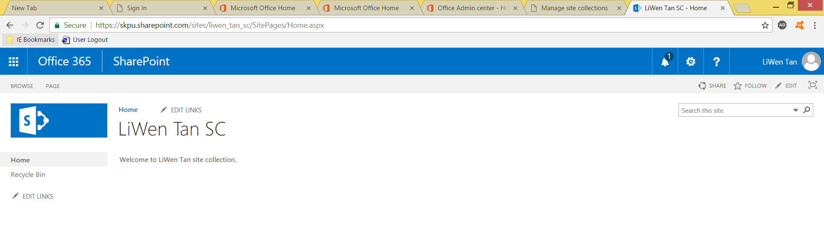

A site collection is created.

**2, Add a user and a group**

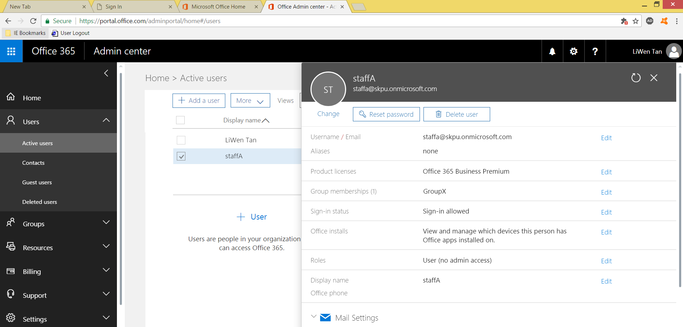

staffA is added to the GroupX

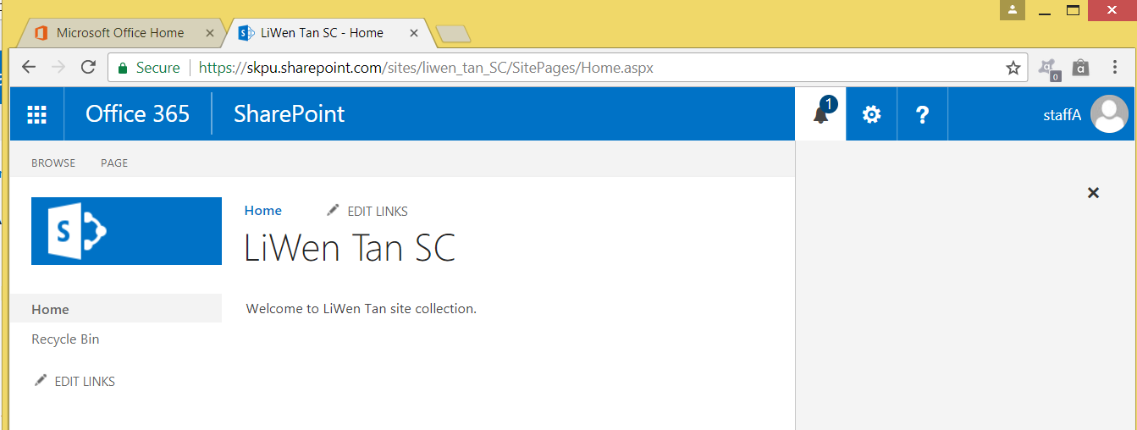

staffA can now access the page, after administrator’s approval